

SCHOOL OF SCIENCE AND TECHNOLOGY
DEPARTMENT OF COMPUTER SCIENCE AND INFORMATION SYSTEMS

BACHELOR OF SCIENCE IN CYBERSECURITY

PROGRAMMING II
CIS-PRO-112
Submitted
To
MR. M. CHINGUWO
By
PEPHERO CHISALE (BCS/25/SS/004)
CHSIOMO JERE ( BCS/25/SS/005)
FLORA GOODSON ( BSE/25/SS/006)
TIWONGE NYASULU (BCS/25/SS/017)

30 September 2026
PROJECT REPORT
- PROBLEM IDENTIFICATION
- Using excel built-in functions would have made the data analysis more static because if a country or two have been deleted from the data set then to calculate or find other values needed, we will also be required to modify the formulae which is inconvenient for a large data set provided.
- AIM AND OBJECTIVE
- Analyse the world population data by searching through it, filtering countries based on the criteria given, calculate the statistical measures, i.e mean, range, median, standard deviation, generate reports, export highly populated countries.
- PROJECT SCOPE
It’s a single user console app , as it can be used by one user at a time.

- SYSTEM ANALYSIS

  - FUNTIONAL REQUIREMENTS
  - The system must load from the csv file into the program itself
  - System must be able to display the total number of countries
  - System must allow a user to search a country by name or cca3
  - The system must be able to sort countries based on the provided criteria
  - System must find maximum and minimum values which were specified when the project was being initialised
  - System must allow filtering of countries based of criteria
  - System must be able to generate different reports
  - System must be able to do statistical computations, i.e calculate averages, standard deviation, median and range
  - System must a user to select a country a estimate it’s future population

  - NON-FUNCTIONAL REQUIREMENTS
  - The system must not crush in case a user types in an invalid input for example a string where we expect an integer
  - The system must allow the user to navigate by providing some other options for safe exit and should allow to go back to the main menu if user wants to
  - The system must implement Object Oriented Programming concepts (OOP) like inheritance, polymorphism, abstraction, etc.
  - The system must display an appropriate error message for example country not found when searching
- SYSTEM DESIGN

5.1 CLASS DIAGRAM DESIGN
CLASS NAME | TYPE | INHERITS | FUNCTION
Base class | Abstract class | null | Provides the public c interface
Country class | Custom | Base class | Defines the data 17 data fields of a country
Sorting data | custom | Base class | Sort data based on criteria whether in descending and ascending order
Searching data | Custom | Base class | Searches a country by name or cca3
Statistical measures | Custom | Base class | Calculate mean, median, standard deviation and range values
Exporting highly pop countries | Custom | Base class | Export countries with population > 100 000 000
Comparing countries | Custom | Base class | Accepts two countries and compare their statistics
Population systems | Composition | Null | Holds pointers to objects of all engines in the system
Analysis engine | Custom | Base class | Filter countries, classify countries based on density and analyse population from 1970 to 2023
Continent analysis | Custom | Base class | Analyse continents statistics, i.e, number of countries per continent, total population per continent
Future estimation | Custom | Base class | Estimate population of a selected country after 10 years
Data manager | Custom | Base class | Loads 234 countries into a vector
Custom exceptions | exceptions | exceptions | Uses a try catch block to trace and throw errors from the program
Extreme value countries | Custom | Base class | Identifies countries with high and low specified criteria

5.2 DATA FLOW
In the first place, data is read from the csv file into the program through input file in the Data manager class in the data loader function. Population system class allocates memory dynamically to the class engines. Operations will then be performed on the data based on the functionality of a class engine. After the operations are done, the memory needs to be freed hence it is deallocated using a virtual destructor from the country class. This enables the trash or residuals from the operations to be cleared from the memory.

- PROJECT FILE STRUCTURRE
- Base_class.h
- Custom_exceptions.h
- Data_manager.h / cpp
- Analysis_engine.h/cpp
- Comparing_countries.h/cpp
- Country_class.h /cpp
- Continent_analysis.h /cpp
- Exporting_highly_pop_countries.h/cpp
- Future_estimation.h/cpp
- Main.cpp
- Population_systems.h/cpp
- Report_generator.h/cpp
- Search-engine.h /cpp
- Sorting_data.h/cpp
- Statistical_measures.h/cpp

- TESTING AND VALIDATION
  - unit testing
Every group member tested their modules individually.
  - integration testing
Testing the module against data which has been loaded into the program.
  - system testing
Testing the entire program at once.
- DEBUGGING
- When doing the standard deviation module, the function was returning the mean instead of the standard deviation.
- When loading data, field like growth rate and world percentage have a percentage symbol which needs to be trimmed before being converting
- CONCLUSION
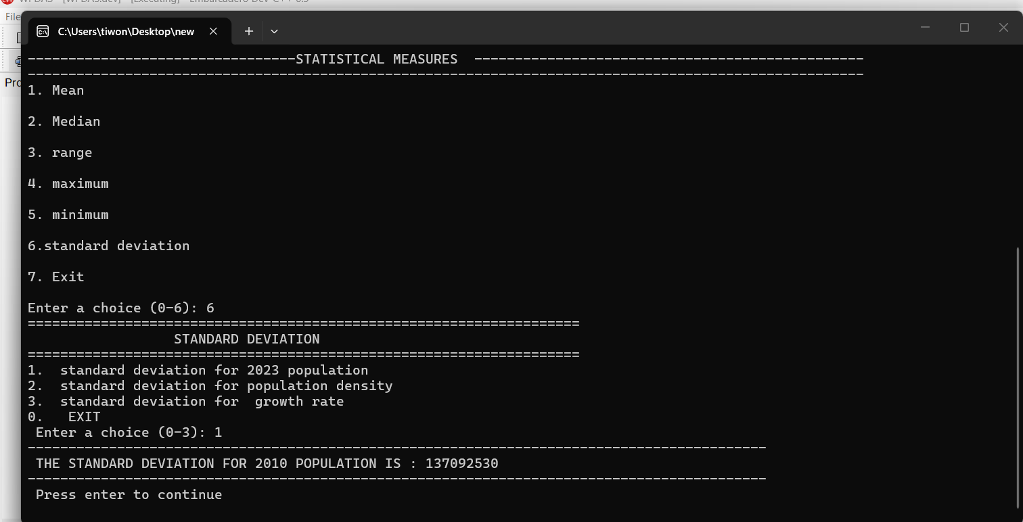

As seen in the screenshot above, the program is able to execute.

